**Projeto: Projeto SIM**

**DET: Projeto_SIM_DT_DW_06_[Alocação de Espaço]**

|  |  |  |  |
| --- | --- | --- | --- |
| **Version History** | | | |
| Version: | Date: | Description of the changes in version: | Author: |
| 1.0 | 31/08/2015 | Initial Version | Manish Subedi |
| 1.1 | 07/09/2015 | Portuguese to English Translation | Bipin Pandey |
| 1.2 | 14/09/2015 | Document Review | Leandro Ap. Tuzi |
|  |  |  |  |
|  |  |  |  |
|  |  |  |  |

|  |  |  |  |
| --- | --- | --- | --- |
| **Information About Document** | | | |
| Issue/Title: | Projeto_SIM_COD_DW_29_[Alocação de Espaço] | |
| Responsible: | Leandro Ap.Tuzi | | |
| Notes: |  | | |
| Areas Involved (cross): | Representative: | Involved Programs: | |
|  |  |  | |
|  |  |  | |
|  |  |  | |
|  |  |  | |
|  |  |  | |

Content

1 Goals Demand 3

1.1 Related Documents 3

1.2 Glossary 3

2 Tests to be performed 3

2.1 Evidence of Test Cases 5

2.1.1 Check whether nb_spacealllocsde.ksh script runs successfully 5

2.1.2 Check package SDE_NB_Retail_SpaceAllocationFact successfully runs in ODI: 5

2.1.3 Count the number of records insert/updated in ODI interface (SDE_Retail_SpaceAllocationStageLoad): 5

2.1.4 Select data in staging table 6

2.1.5 Match the count of records in ODI and Database staging table 6

2.1.6 Check whether nb_spacealllocsil.ksh script runs successfully 6

2.1.7 Check package SIL_NB_Retail_SpaceAllocationFact successfully runs in ODI. 6

2.1.8 Count the number of records insert/updated in ODI interface (SIL_Retail_SpaceAllocationTempLoad) 7

2.1.9 Count the number of records insert/updated in ODI interface (SIL_Retail_SpaceAllocationLoad): 7

2.1.10 Select data in Target tables 8

2.1.11 Match the count of records in ODI and Database Target table 8

3 Final Considerations 8

4 Attachments 8

# Goals Demand

This document aims to report everything must be validated after the development of *SDE_NB_Retail_SpaceAllocationFact and SIL_NB_Retail_SpaceAllocationFact* package in ODI.

During the basic validations here reported, the results should be completed in order to verify if the project requirements are met and are working as specified.

## Related Documents

|  |  |  |
| --- | --- | --- |
| **Name** | **Version** | **Location** |
| Projeto_SIM_DT_DW_06_[Alocação de Espaço] | 0.1 | Sharepoint Renner > Documentos > Retail > Documentos Técnicos > DW > |

## Glossary

|  |  |
| --- | --- |
| **Acronym** | **Description** |
| ODI | Oracle Data Integrator |
| SDE | Source Dependent Extraction |
| SIL | Source Independent Load |
| PLP | Post Loading Program |

# Tests to be performed

Status (1): N –Not meet / P –Meets partly / T –Fully Meets

Severity (2): A – High / M – Medium/ B – Low

|  |  |  |  |  |  |  |  |  |  |
| --- | --- | --- | --- | --- | --- | --- | --- | --- | --- |
| **Steps and Tests to be run** | | | | | | | | | |
| **#** | **Test** | **Expected Results** | **Status (1)** | | | **Reason** | **Action Required** | **Date Execution** | **Sev. (2)** |
| **N** | **P** | **T** |
| 1 | *Check whether nb_spacealllocsde.ksh script run successfully* | *Program should run successfully with status* ***DONE*** |  |  | *X* |  |  | *31/08/2015* | *B* |
| 2 | *Check whether SDE_NB_Retail_SpaceAllocationFact Package successfully run in ODI.* | *Package should run successfully with all green icons in the package objects.* |  |  | *X* |  |  | *31/08/2015* | *B* |
| 3 | *Count the number of records insert/updated in ODI interface(SDE_Retail_SpaceAllocationStageLoad)* | *60 rows must be inserted in NB_SPACE_ALLOC_DP_LC_DY_FS table* |  |  | *X* |  |  | *31/08/2015* | *B* |
| 4 | *Select count in Staging tables* | *Count : 60 rows in NB_SPACE_ALLOC_DP_LC_DY_FS table* |  |  | *X* |  |  | *31/08/2015* | *B* |
| 5 | *Match the count of records in ODI and Database staging table* | *Count of records should equal in ODI and staging tables* |  |  | *X* |  |  | *31/08/2015* | *B* |
| 6 | *Check whether nb_spacealllocsil.ksh script run successfully* | *Program should run successfully with status* ***DONE*** |  |  | *X* |  |  | *31/08/2015* | *B* |
| 7 | *Check whether the package SIL_NB_Retail_SpaceAllocationFact successfully runs in ODI.* | *Package should run successfully with all green icons in the package objects.* |  |  | *X* |  |  | *31/08/2015* | *B* |
| 8 | *Count the number of records insert/updated in ODI interface(SIL_Retail_SpaceAllocationTempLoad)* | *90600 rows inserted in NB_SPACE_ALLOC_DP_LC_DY_TMP table* |  |  | *X* |  |  | *31/08/2015* | *B* |
| 9 | *Count the number of records insert/updated in ODI interface(SIL_Retail_SpaceAllocationLoad)* | *90600 rows inserted in NB_SPACE_ALLOC_DP_LC_DY_F table* |  |  | *X* |  |  | *31/08/2015* | *B* |
| 10 | *Select count in Target tables (NB_SPACE_ALLOC_DP_LC_DY_TMP and NB_SPACE_ALLOC_DP_LC_DY_F)* | *Count : 90600 rows in NB_SPACE_ALLOC_DP_LC_DY_TMP table*  *Count : 90600 rows in NB_SPACE_ALLOC_DP_LC_DY_F table* |  |  | *X* |  |  | *31/08/2015* | *B* |
| 11 | *Match the count of records in ODI and Database Target table* | *Count of records should equal in ODI and target tables* |  |  | *X* |  |  | *31/08/2015* | *B* |
|  | | **Total por Status** | 14 | 14 | 11 |

## Evidence of Test Cases

### Check whether nb_spacealllocsde.ksh script runs successfully

  


The program ran successfully.

### Check package SDE_NB_Retail_SpaceAllocationFact successfully runs in ODI:

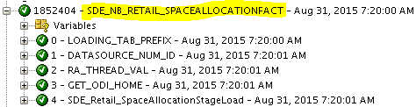

### Count the number of records insert/updated in ODI interface (SDE_Retail_SpaceAllocationStageLoad):

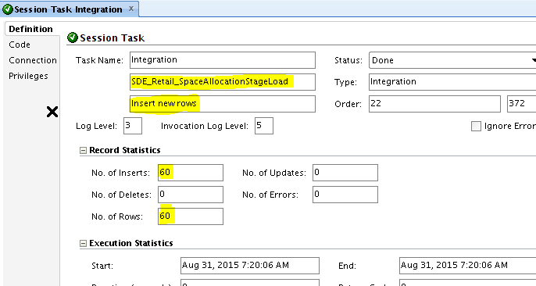

60 rows inserted in NB_SPACE_ALLOC_DP_LC_DY_FS table.

### Select data in staging table

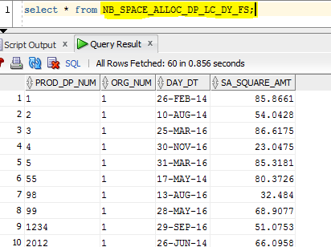   
60 rows inserted in NB_SPACE_ALLOC_DP_LC_DY_FS table

### Match the count of records in ODI and Database staging table

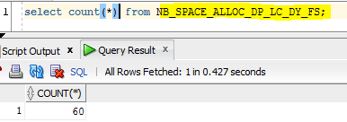  
Count of records are matched in ODI and database staging tables (Count=13).

### Check whether nb_spacealllocsil.ksh script runs successfully

  
  
  
Program ran successfully

### Check package SIL_NB_Retail_SpaceAllocationFact successfully runs in ODI.

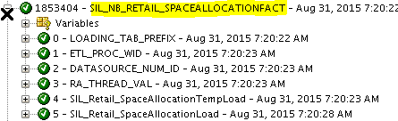

### Count the number of records insert/updated in ODI interface (SIL_Retail_SpaceAllocationTempLoad)

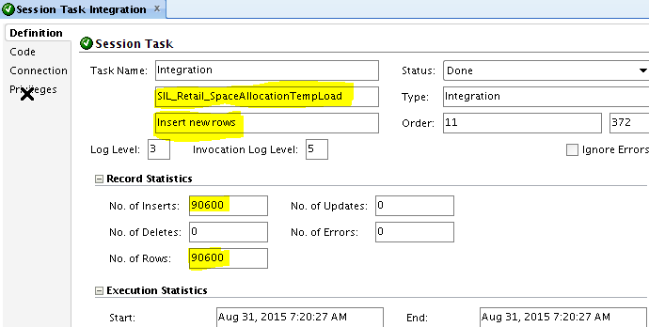  
  
 90600 rows inserted in NB_SPACE_ALLOC_DP_LC_DY_TMP table

### Count the number of records insert/updated in ODI interface (SIL_Retail_SpaceAllocationLoad):

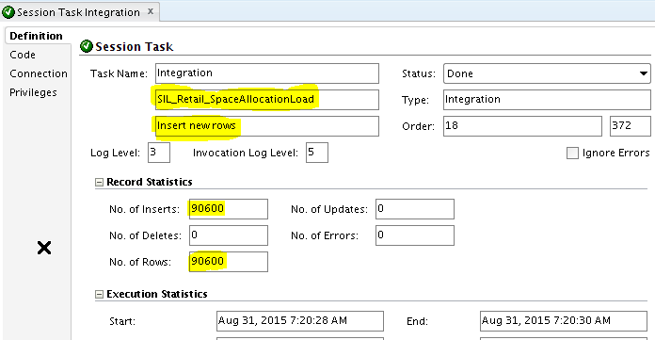

90600 rows inserted in NB_SPACE_ALLOC_DP_LC_DY_F table

### Select data in Target tables

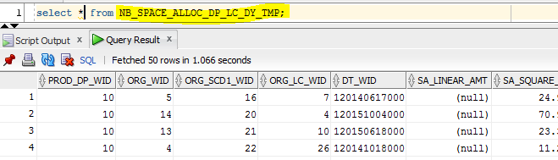  
90600 rows inserted in NB_SPACE_ALLOC_DP_LC_DY_TMP table

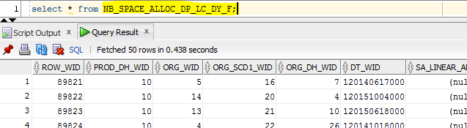  
  
90600 rows inserted in NB_SPACE_ALLOC_DP_LC_DY_F table

### Match the count of records in ODI and Database Target table

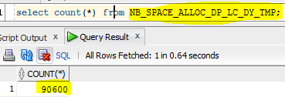

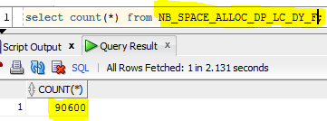

Number of records are matched in ODI and database target tables (Count=90600)

# Final Considerations

N/A.

# Attachments

N/A.